COMPUTER NETWORKS
4. Transport Layer and Application Layer
4.1 Transport Layer: Service primitives, Sockets, Connection management (Handshake), UDP, TCP, TCP state transition, TCP timers, TCP Flow control (sliding Window)
4.2 Application Layer: HTTP, SMTP, Telnet, FTP, DHCP, DNS and Types of Name Server
PAST QUESTIONS:
- Sliding Window Protocol. (D22, M23)
- DHCP. (D22, M23)
- Explain Three Way Handshaking for connection establishment in TCP. (M23)
- Write notes on DNS and Explain components on DNS. (M23)
- Differentiate between TCP and UDP. (D23)
- With the help of suitable example explain sliding window protocol using Go-Back-N technique. (D23)
- Explain with the help of suitable diagram TCP connection management and release? (D23)
- DNS. (D23)
NOTES:

*TCP connection management :-
TCP (Transmission Control Protocol) is one of the main protocols of the Internet protocol suite. It lies between the Application and Network Layers. It is a connection-oriented protocol for communications that helps in the exchange of messages between different devices over a network.
The primary mechanism for connection establishment is the three-way handshake, and connection termination typically involves a four-step termination sequence.
1. TCP Connection Establishment (Three-Way Handshake) -
The connection establishment process uses a three-way handshake to ensure both ends are ready for data transfer.
- SYN (Synchronize): The client initiates a connection by sending a SYN packet to the server. This packet contains an initial sequence number (Seq = x).
- SYN-ACK (Synchronize-Acknowledgement): The server responds to the client with a SYN-ACK packet, acknowledging the client’s SYN request. The SYN-ACK packet contains the server’s initial sequence number (Seq = y) and an acknowledgment number (Ack = x + 1) for the client’s SYN.
- ACK (Acknowledgement): The client sends an ACK packet to the server to acknowledge receipt of the SYN-ACK packet, completing the connection setup (Ack = y + 1).
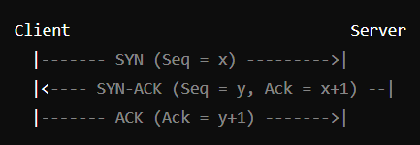
2. Data Transfer -
Once the connection is established, both client and server can start exchanging data packets. This phase continues until all data is transmitted.
3. TCP Connection Termination (Four-Step Termination) -
When one side wants to end the connection, a four-step termination sequence is used.
- FIN (Finish): The endpoint (e.g., client) that wants to terminate the connection sends a FIN packet, indicating that it has finished sending data (Seq = m).
- ACK: The receiving end (e.g., server) sends an ACK packet to acknowledge the FIN, indicating readiness to close the connection on its side (Ack = m + 1).
- FIN: When the server is ready to close, it sends its own FIN packet (Seq = n).
- ACK: The client responds with an ACK to acknowledge the server’s FIN (Ack = n + 1).
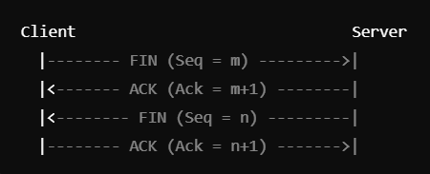

*Three Way Handshaking in TCP :-
The TCP 3-Way Handshake is a fundamental process that establishes a reliable connection between two devices over a TCP/IP network. It involves three steps: SYN (Synchronize), SYN-ACK (Synchronize-Acknowledge), and ACK (Acknowledge).
During the handshake, the client and server exchange initial sequence numbers and confirm the connection establishment.
The TCP 3-Way Handshake is a fundamental process used in the Transmission Control Protocol (TCP) to establish a reliable connection between a client and a server before data transmission begins. This handshake ensures that both parties are synchronized and ready for communication.
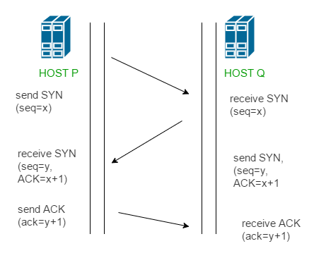
Steps involved -
- Step 1 (SYN): In the first step, the client wants to establish a connection with a server, so it sends a segment with SYN (Synchronize Sequence Number) which informs the server that the client is likely to start communication and with what sequence number it starts segments with
- Step 2 (SYN + ACK): Server responds to the client request with SYN-ACK signal bits set. Acknowledgement (ACK) signifies the response of the segment it received and SYN signifies with what sequence number it is likely to start the segments with
- Step 3 (ACK): In the final part client acknowledges the response of the server and they both establish a reliable connection with which they will start the actual data transfer

*Sliding Window Protocol :-
The Sliding Window Protocol is a key computer networking technique for controlling the flow of data between two devices. It guarantees that data is sent consistently and effectively, allowing many packets to be sent, maximizing the use of available bandwidth.
In Go-Back-N, the sender can send multiple data packets without waiting for an acknowledgement for each one. However, it can only send a certain number of packets (this is called the “window size”). If one packet is lost or not acknowledged, the sender must go back and resend that packet and all the packets that followed it, even if they were received correctly. For example, if packets 1, 2, 3, 4, and 5 are sent and packet 3 gets lost, the sender will have to resend packets 3, 4, and 5, even if 4 and 5 were received.
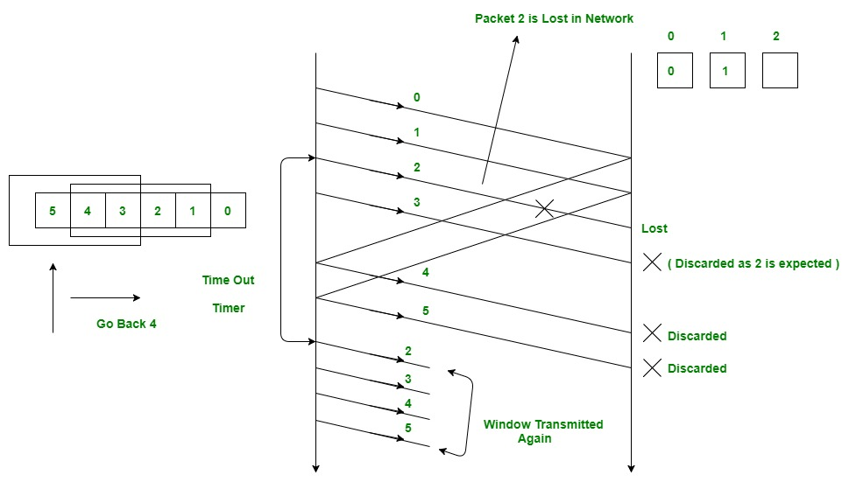
*Dynamic Host Configuration Protocol (DHCP) :-
DHCP stands for Dynamic Host Configuration Protocol, it is a network protocol used to automate the process of assigning IP addresses and other network configuration parameters to devices (such as computers, smartphones, and printers) on a network.
DHCP helps enterprises to smoothly manage the allocation of IP addresses to the end-user clients’ devices. It is the critical feature on which the users of an enterprise network communicate. DHCP simplifies network configuration by dynamically assigning IP addresses.

*Domain Name System (DNS) :-
A DNS (Domain Name System) server translates domain names into IP addresses, allowing users to access websites by typing domain names into their web browsers.
DNS resolves names to numbers, to be more specific it resolves domain names to IP addresses. So if you type in a web address in your web browser, DNS will resolve the name to a number because the only thing computers know are numbers.
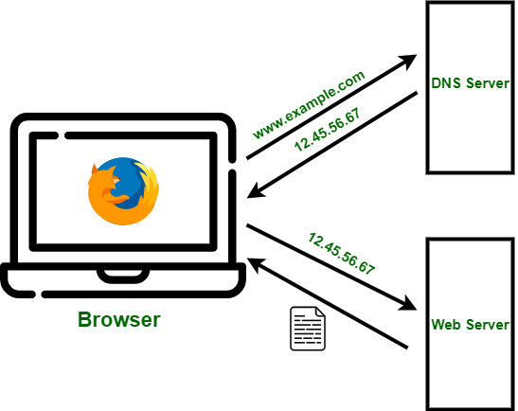
when you type google.com on your web browser DNS server will search through its cache to find a matching IP address for that domain name, and when it finds it will resolve that domain name to IP address of Google web site, and once that is done then your computer is able to communicate with a Google web server and retrieve the webpage.
Here are the main components of DNS:
- Domain Names: Structured names (e.g., .com, .org, etc.), helping users access websites with easy-to-remember names instead of numerical IP addresses.
- DNS Resolvers: Also known as DNS clients, these are services or applications on devices that initiate DNS queries to resolve domain names.
- Name Servers: DNS servers store DNS records and respond to queries from clients. The main types are:
  - Root Name Servers: The highest level in the DNS hierarchy, directing queries to the appropriate top-level domain (TLD) servers.
  - Top-Level Domain (TLD) Servers: Manage the second level in DNS hierarchy, like .com, .org, .net, and country-specific domains like .us, .uk.
  - Authoritative Name Servers: Hold the DNS records for specific domains and provide final answers to DNS queries.
- DNS Records: Stored information that provides details about domains. Key DNS record types include:
  - A (Address) Record: Maps a domain to an IPv4 address.
  - AAAA (Quad-A) Record: Maps a domain to an IPv6 address.
  - CNAME (Canonical Name) Record: Points one domain to another domain (aliasing).
  - MX (Mail Exchange) Record: Directs email to specific mail servers.
  - TXT (Text) Record: Stores text information for verification and authentication purposes.
  - NS (Name Server) Record: Lists authoritative servers for the domain.
- Zones: A zone is a portion of the DNS namespace managed by a particular organization. Each zone has an authoritative name server responsible for answering queries within that domain.
- Reverse DNS (rDNS): Unlike the standard DNS, which maps domain names to IP addresses, rDNS maps IP addresses back to domain names, usually handled through PTR records.
- Caching: Temporary storage of DNS responses to improve speed.
These components work together to provide a seamless experience when accessing resources on the internet by efficiently translating domain names into IP addresses.

*TCP vs UDP :-

Transmission Control Protocol (TCP) | User Datagram Protocol (UDP)
TCP is a connection-oriented protocol. Connection orientation means that the connection needs to be established before the data is transmitted over the network. | UDP is a connectionless protocol, which means that it sends the data without checking whether the system is ready to receive or not.
TCP is a reliable protocol as it provides assurance for the delivery of data packets. | UDP is an unreliable protocol as it does not take the guarantee for the delivery of packets.
The size of TCP is 20 bytes. | The size of the UDP is 8 bytes.
An acknowledgment segment is present. | No acknowledgment segment.
TCP performs error checking by using a checksum. When the data is corrected, then the data is retransmitted to the receiver. | It does not perform any error checking, and also does not resend the lost data packets.
TCP is comparatively slower than UDP. | UDP is faster, simpler, and more efficient than TCP.
Retransmission of lost packets is possible in TCP, but not in UDP. | There is no retransmission of lost packets in the User Datagram Protocol (UDP).
TCP is heavy-weight. | UDP is lightweight.
Uses handshakes such as SYN, ACK, SYN-ACK | It’s a connectionless protocol i.e. No handshake
TCP doesn’t support Broadcasting. | UDP supports Broadcasting.
TCP is used by HTTP, HTTPs , FTP , SMTP and Telnet . | UDP is used by DNS , DHCP , TFTP, SNMP , RIP , and VoIP .
The TCP connection is a byte stream. | UDP connection is a message stream.
This protocol is mainly used where a secure and reliable communication process is required, like military services, web browsing, and e-mail. | This protocol is used where fast communication is required and does not care about the reliability like VoIP, game streaming, video and music streaming, etc.

